National Coral Reef Monitoring Program

Climate Monitoring Brief: Dry Tortugas National Park

Atlantic Oceanographic & Meteorological Laboratory Coral Program University of Miami Cooperative Institute of Marine and Atmospheric Science National Oceanic Atmospheric Administration

N. Besemer, A. Palacio, M. Jankulak, G. Kolodziej, I. Enochs

July 2021

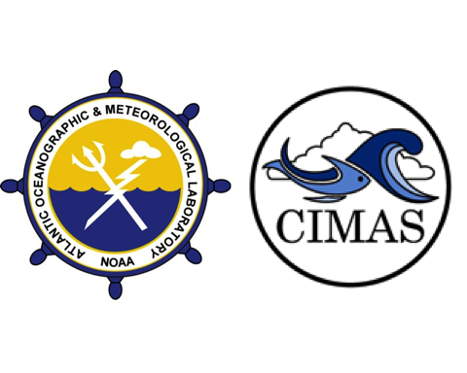

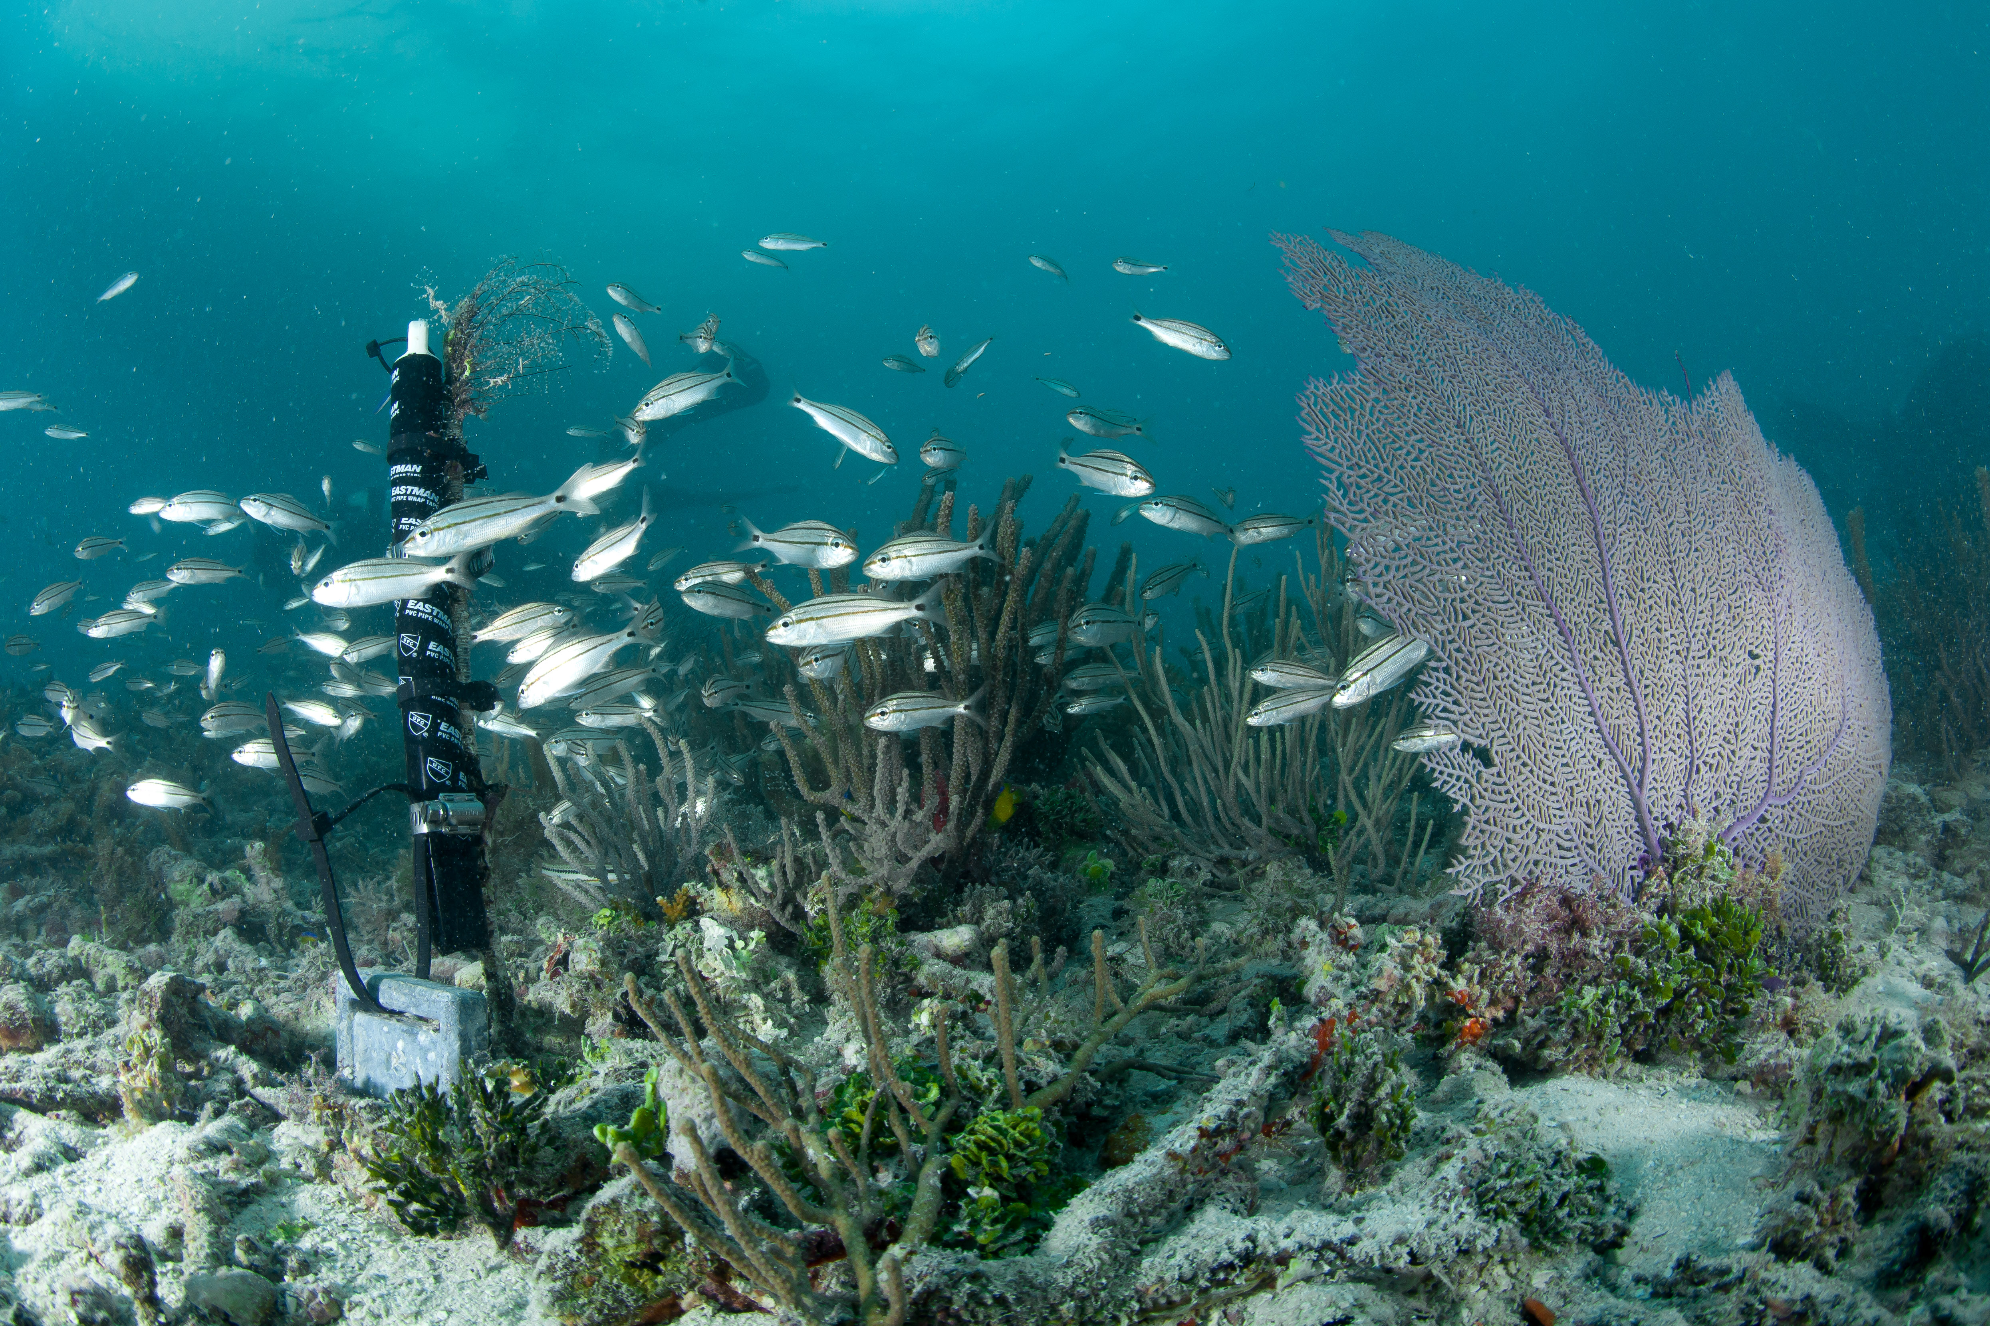

New Subsurface Temperature Recorder deployed at White Shoal in Dry Tortugas National Park

### 

### About this summary brief

The NOAA Atlantic Oceanographic and Meteorological Laboratory (AOML) conducts the long-term National Coral Reef Monitoring Program (NCRMP) to track the status and trends of coral reef ecosystems of the U.S. Atlantic and Caribbean coral reef jurisdictions. This FY21 summary brief provides an overview of the most recent survey efforts.

### Expedition summary

* The most recent NCRMP Atlantic climate monitoring took place at Dry Tortugas National Park from June 24th to June 29th 2021
* Four different sites were visited by 5 team members completing a total of 63 dives.
* These sites represent temporal‐resolution monitoring with moored instruments at fixed time‐series which are placed on depth gradient to assess how vertical structure affects reef status and trends.

### 

### Data collection

* Subsurface **temperature** recorders (STRs) were recovered and redeployed at all 4 study sites (Fig. 1), accounting for 1.1 million observations:
  + Pulaski Shoal (1m): 311,609 observations
  + White Shoal (5m): 311,213 observations
  + Bird Key Reef (15m): 311,560 observations
  + Black Coral Rock (25m): 165,695 observations
* At the Bird Key Reef, short term instruments (72h) were deployed to monitor daily fluctuations in:
  + **Current**: 880 observations
  + **pH**: 879 observations
  + **Light**: 876 observations
  + **Carbonate Chemistry**: 24 samples collected
* Additionally, changes in benthic cover and carbonate production were monitored at Bird Key Reef by recording:
  + **Bioerosion**: 5 Bioerosion Monitoring Units (BMUs) collected, 10 redeployed
  + **Calcification**: 5 Calcification Accretions Units (CAUs) collected, 5 redeployed
  + **Benthic cover**: 6 landscape mosaics
  + **Carbonate budget surveys**: Benthic cover, sponge, urchin and parrotfish surveys completed at 6 transects

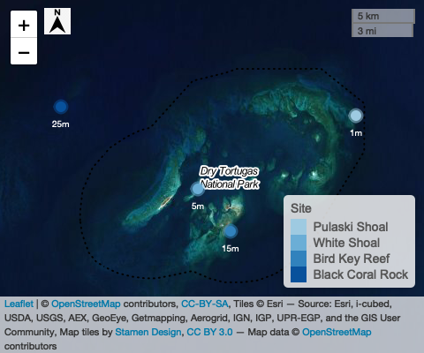

**Figure 1:** Study sites and depths in Dry Tortugas National Park area

#### 

#### Temperature

Three years of temperature measurements were retrieved and processed from all 4 sites (Fig. 1). Temperature was measured using SeaBird Electronics Subsurface Temperature Recorders (STR)s that collected data at 5-minute intervals.

Temperatures were similar among the 1m, 5m and 15m depths with the lowest temperatures recorded during February 2021 (20.8, 20.7, and 19.9 $​^{∘}$ C, respectively) and the the higest temperatures during the summer of 2019 and 2020 (31.7, 31.6, and 31.5 $​^{∘}$ C, respectively). Though the 25m STR stopped recording on February 7, 2020, it detected consistent temperature stratification at this site during the summers. Temperatures at 25m were on average 5-6 $​^{∘}$ C lower during summer 2018, and 1 $​^{∘}$ C lower during summer 2019, compared with the values at other depths (Fig. 2).

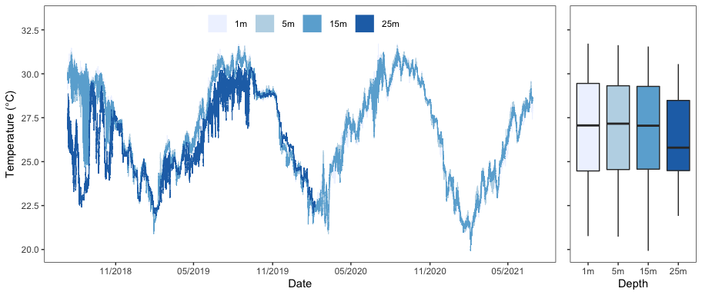

**Figure 2:** Temperature conditions at four sites in the Dry Tortugas representing a depth gradient: Pulaski Shoal Lighthouse (1m) White Shoal (5m), Bird Key Reef (15m), and Black Coral Rock (25m). Data were collected from November 2018 to June 2021, with the exception of the 25m STR that recorded until February 7th 2020.

#### Diurnal Suite Deployment

At Bird Key Reef additional instruments were deployed for a 72-hour diurnal suite that monitored pH, temperature, light and current speed (Fig. 3). The SeaFET pH logger, EcoPAR and Tiltmeter collected measurements at 5-minute intervals.

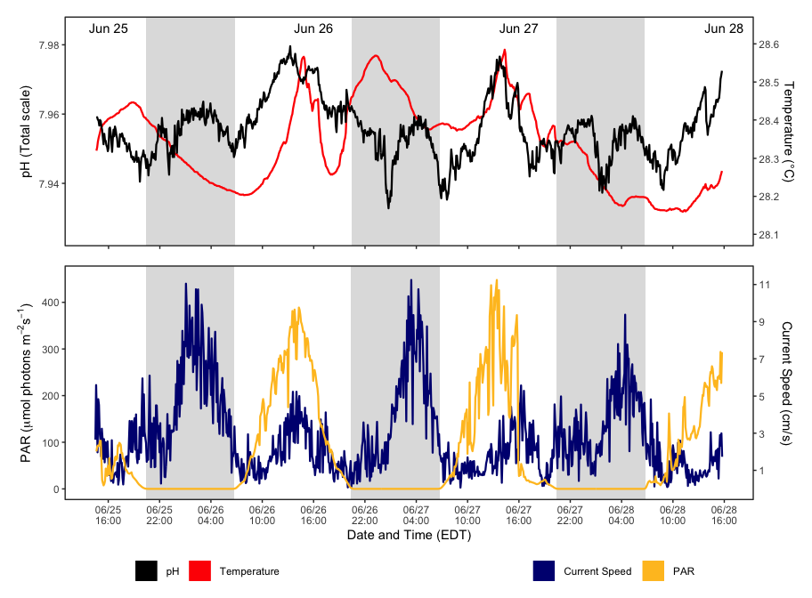

**Figure 3:** Bird Key Reef (15m) diurnal suite monitoring from June 25th to 28th. Top panel: pH and temperature from SeaFET. Bottom panel: Photosynthetically Available Radiation (PAR) and current speed from EcoPAR and Tiltmeter. Grey blocks denote night time throughout sequence of the plot. Instruments measured parameters every 5 minutes.

As part of the diurnal suite, discrete water samples were collected at three-hour intervals (n=24) using Subsurface Automatic Samplers (SAS). These samples will be analyzed for Total Alkalinity (TA), Dissolved Inorgan ic Carbon (DIC), and Spectrophotometric pH (SpecpH). Using these metrics we can get the calculated values for pCO2 and aragonite saturation state. For more information on SAS visit <https://www.coral.noaa.gov/accrete/sas/>

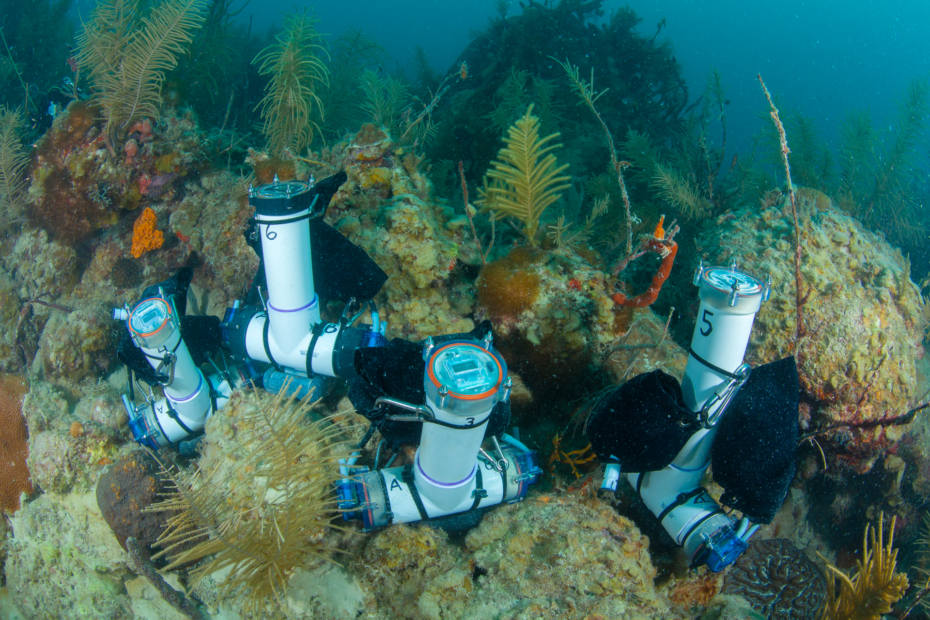

Submerged SAS collect water samples every 3 hours

#### 

#### Other Deliverables

**Calcification Accretion Units (CAUs)** and **Bioerosion Monitoring Units (BMUs)** were collected and redeployed for the next sampling cycle.

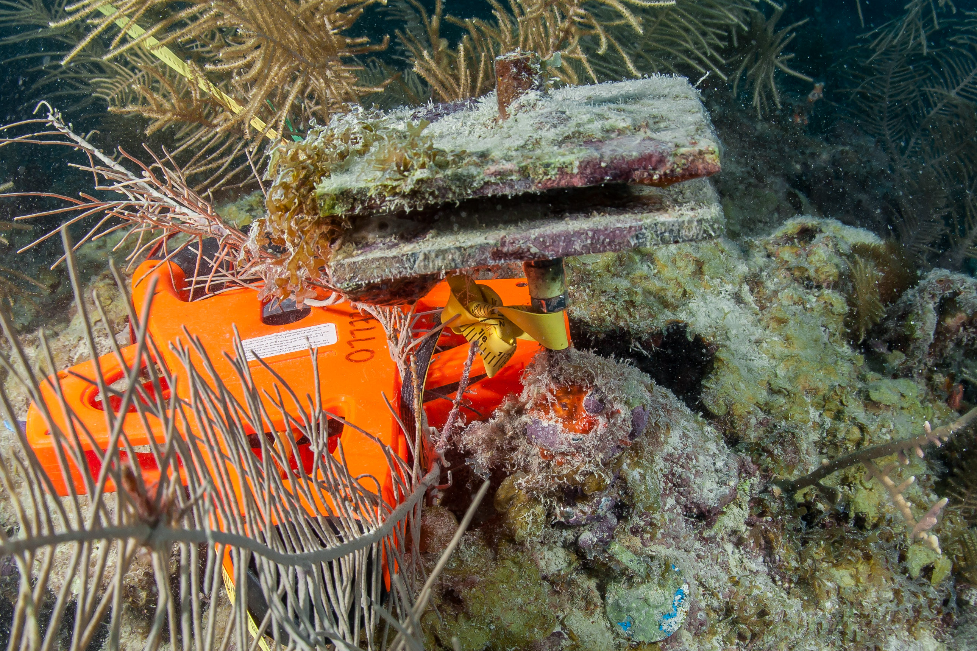

CAU and BMU pair before retreval after being deployed for 3 years. CAUs are 2 parallel PVC plates to quantify settled accretors. BMU is mounted coral skeleton installed at the base of the metal stake and has been encrusted.

CAUs are processed by the Pacific Climate group and the data will be available within a year. BMUs will be dried and cleaned using a hydrogen peroxide solution. These samples will be weighed and scanned using a Macro CT scanner and then compared to their pre-scans to quantify bioerosion. Data will be available in a year. Please reference previous datasets for more information.

**Landscape mosaics** (n=6) and **carbonate budget** surveys (n=6) were completed to monitor changes in benthic cover and carbonate production

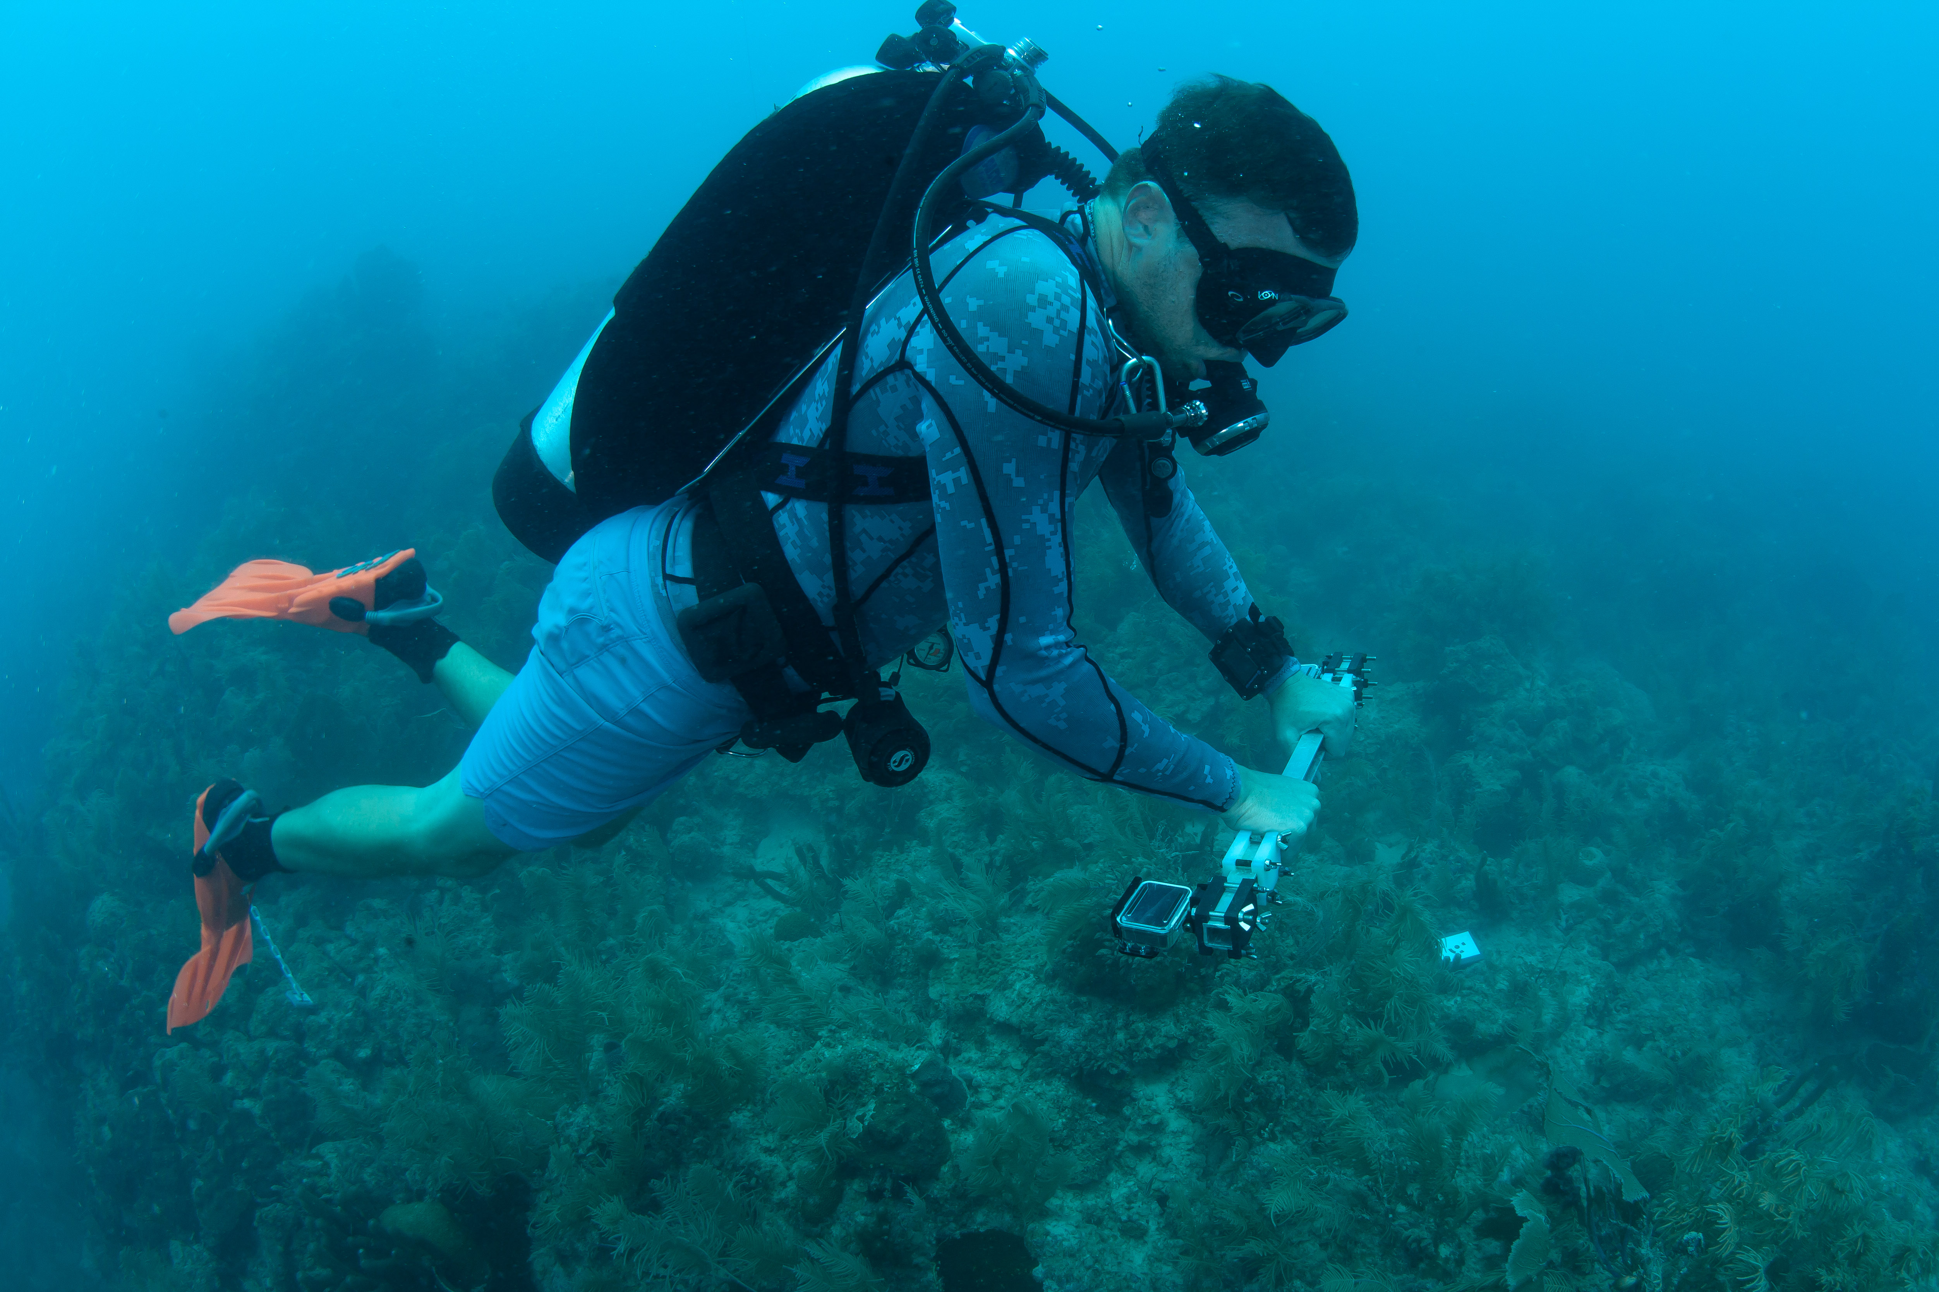

Scientist N. Formel collects images to create the orthorectified landscape mosaics

### 

### About the monitoring program

AOML’s climate monitoring is a key part of the National Coral Reef Monitoring Program of NOAA’s Coral Reef Conservation Program (CRCP), providing integrated, consistent, and comparable data across U.S. Managed coral reef ecosystems. CRCP monitoring efforts aim to:

* Document the status of reef species of ecological and economic importance.
* Track and assess changes in reef communities in response to environmental stressors or human activities.
* Evaluate the effectiveness of specific management strategies and identify actions for future and adaptive responses.

### 

### Point of Contact

Atlantic Climate team lead: [nicole.besemer@noaa.gov](mailto:nicole.besemer@noaa.gov)

Principal Investigator: [ian.enochs@noaa.gov](mailto:ian.enochs@noaa.gov)

NCRMP Coordinator: [erica.towle@noaa.gov](mailto:erica.towle@noaa.gov)

### For more information

Coral Reef Conservation Program: <http://coralreef.noaa.gov>

NCRMP climate monitoring: <https://www.coris.noaa.gov/monitoring/climate.html>

NOAA Atlantic Oceanographic and Meteorological Laboratory: <http://www.aoml.noaa.gov/>

[Florida Coral Reef Status Report 2020](https://www.coris.noaa.gov/monitoring/status_report/docs/FL_508_compliant.pdf)

[National Coral Reef Status Report 2020](https://repository.library.noaa.gov/view/noaa/27295)

### Acknowledgements

These efforts were jointly funded by NOAA’s CRCP and OAP. We would like to thank the National Park Service and Florida Keys National Marine Sanctuary for permitting support and the ANGARI Foundation for field support.

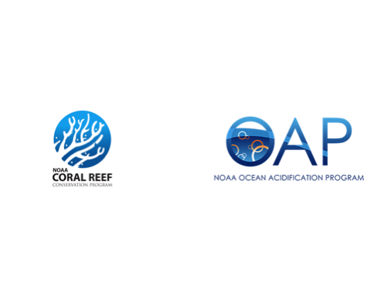

### 

### Our Team

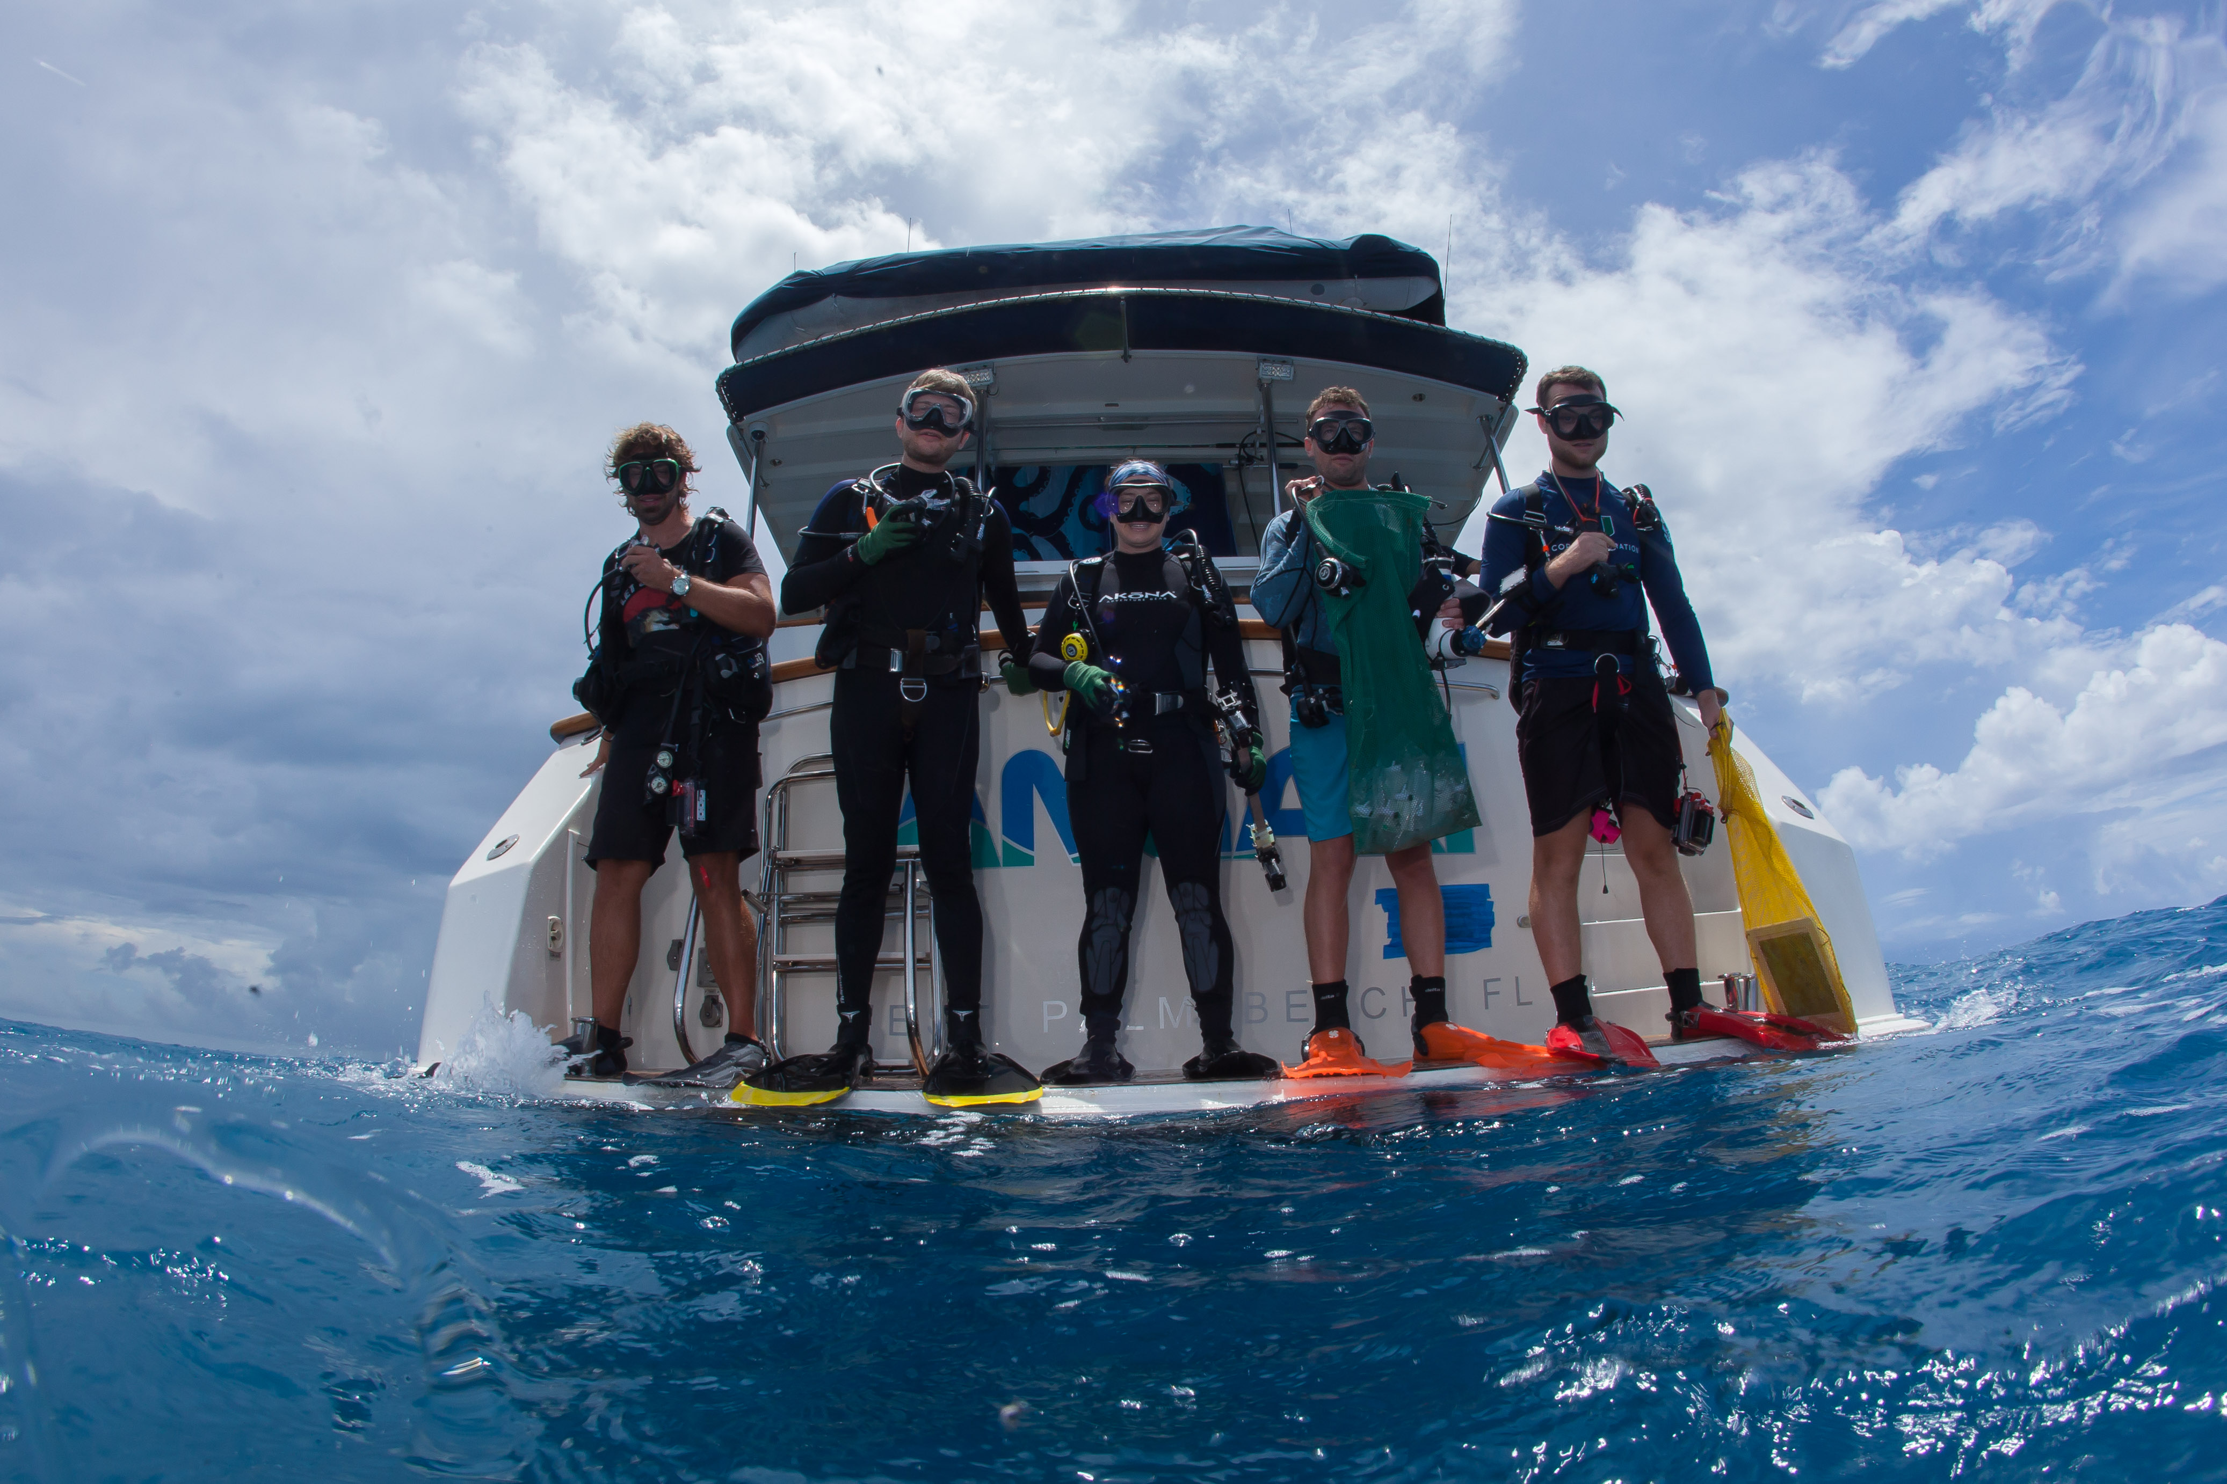

**Field team members**: A. Mayfield, G. Kolodziej, N. Besemer, N. Formel, P. Kiel

**Additional lab members involved with NCRMP**: I. Enochs, B. Chomitz, A. Boyd, M. Jankulak, A. Palacio-Castro